**Flipper Zero - NFC**

**NFC Reader Wiring**

An Arduino Mega 2560 was used in the demonstration with an RC522 module to read the blocks and sectors on the MIFARE NFC card. The wiring diagram is below. Most microcontrollers such as an Arduino UNO or microcomputers will work such as a Raspberry Pi since the NFC reader module uses 3.3v control voltage.

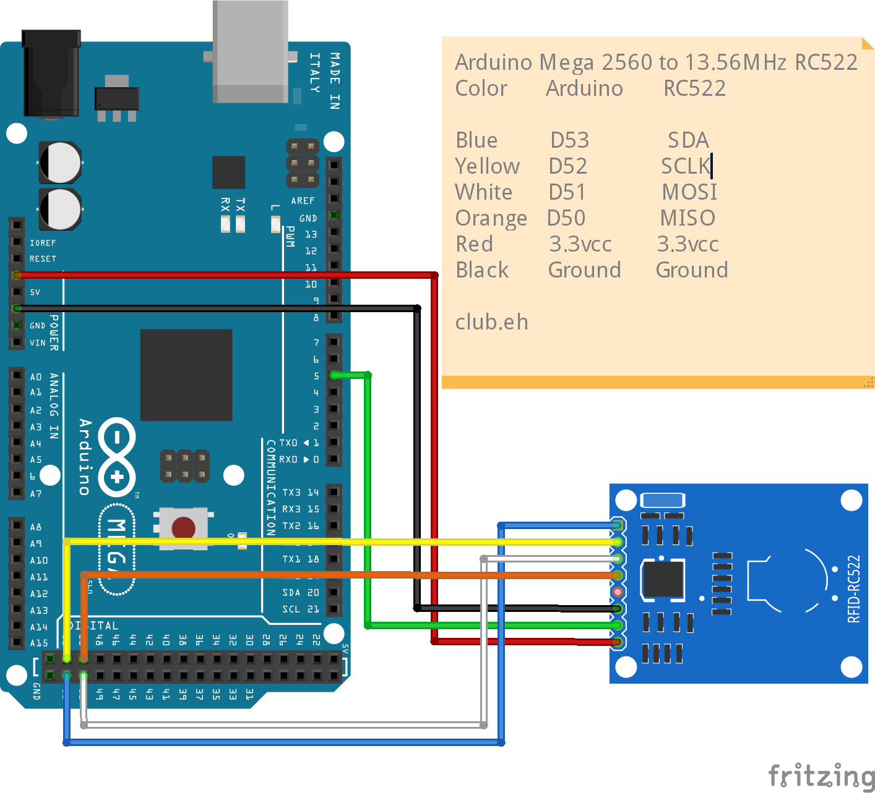

**Freeware Used: Search online to download**

* We used the **qFlipper** freeware to display the Flipper Zero screen on the computer. This software also allows for file transfers to and from the flipper as well as complete control over the Flipper Zero through the computer.
* We also used the **Arduino IDE** to program the NFC reader to read the contents of the card. The script used for reading the cards with the reader were examples scripts from the imported RC522 library in the Arduino IDE
* Cool term was the serial monitor and capture that we used to create .txt files of the card contents. <https://freeware.the-meiers.org/>

